1. Use Cases
2. Noun List
3. Conceptual Object Model
4. Assigning responsibilities
5. Class diagram

1. USE CASES

Title: Add new entry
Actor: User
Scenario:
1. User adds a link the educational article/video
2. User adds a title
3. User adds a short description
4. User adds tags
5. User submits entry

Title: Search entry
Actor: User
Scenario:
1. User provides search parameters
2. User submits search
3. System lists matches

Title: Delete entry
Actor: User
Scenario:
1. User selects entries to delete
2. System asks for confirmation
3. System removes entries

Title: Edit entry
Actor: User
Scenario:
1. User selects entry to edit
2. System asks for confirmation
3. System edits entry

Title: Comment on entry
Actor: User
Scenario:
1. User chooses an entry or parent comment
2. User makes comment

Title: Delete Comment
Actor: User
Scenario:
1. User chooses an entry or parent comment
2. User deletes comment

Title: Edit Comment
Actor: User
Scenario:
1. User chooses an entry or parent comment
2. User edits comment

Title: Create new group
Actor: User
Scenario:
1. User creates a name for the group
2. User sets priviliges for other users (private, public)
3. System checks if the name is available
4. System creates a new user group

Title: Join group
Actor: User
Scenario:
1. User selects group
2. User asks for invitation if the group is private

Title: Leave group
Actor: User
Scenario:
1. User selects a group
2. User chooses to leave the group
3. System asks for confirmation
4. System removes user from the group
5. If the user was the last person leaving the group the group is deleted

Title: Share entry
Actor: User
Scenario:
1. User selects an entry
2. User chooses to share entry
3. System lists possible groups
4. User chooses group
5. System checks if the user can share a link within the group
5. System checks if the entry is shared in the group
6. If not system shares link with the group

Title: Rate entry
Actor: User
Scenario:
1. User selects an entry
2. User submits rating
3. System adds rating

Title: Rate comment
Actor: User
Scenario:
1. User selects a comment
2. User submits a rating
3. System adds rating

2. NOUN LIST

User
Entry (same as a Link)
Entry List
Title (property of Entry)
Link
Short Description (property of Entry)
Tag
Search Parameters
Group
Comment
System
Rating

3. CONCEPTUAL OBJECT MODEL

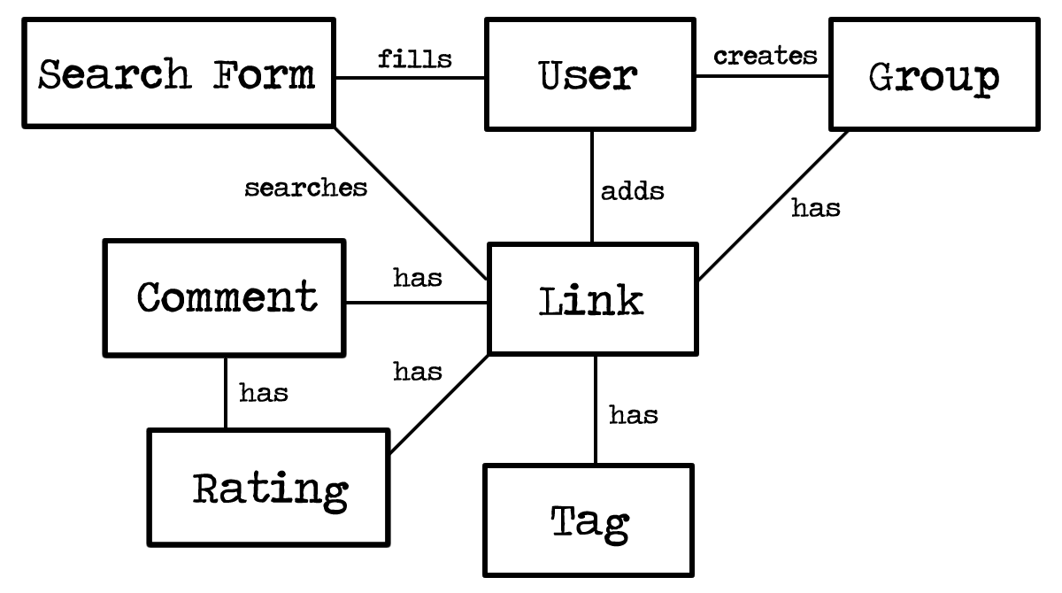

4. ASSIGNING RESPONSIBILITIES

submit entry
submit search
delete entry
edit entry
create group
invite user
remove user
delete group
share entry
rate entry
rate comment
comment on entry
comment on comment
delete comment
edit comment

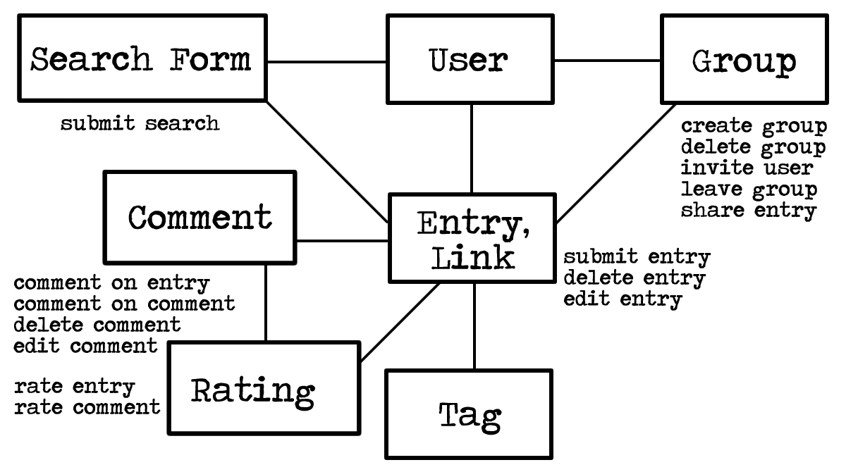

5. CLASS DIAGRAM

ENTRY / LINK
id: Number
url: String
title: String
description: String
tag: Array
isUrlValid (String): Boolean
formatTag (String): String
addTag (String): Array
submitEntry ()
deleteEntry ()
editEntry ()

USER
id: Number
name: String
password: String
email: String
entries: Array
createUser ()
usernameValid ()
passwordValid ()
emailValid ()

COMMENT
id: Number
comment: String
addComment ()
editComment ()
deleteComment ()

RATING
id: Number
entryRatingPositive: Number
entryRatingNegative: Number
commentRating: Number
rateEntry ()
rateComment ()

SEARCH / TAG
listOfTags: Array
globalSearch: Boolean
addTag ()
isGlobal ()
submitSearch()

GROUP
id: number
name: String
members: Array
entries: Array
createGroup ()
deleteGroup ()
inviteUser ()
leaveGroup ()
shareEntry ()

